Windsor Warrior 2024
THE MOVEMENT STANDARDS

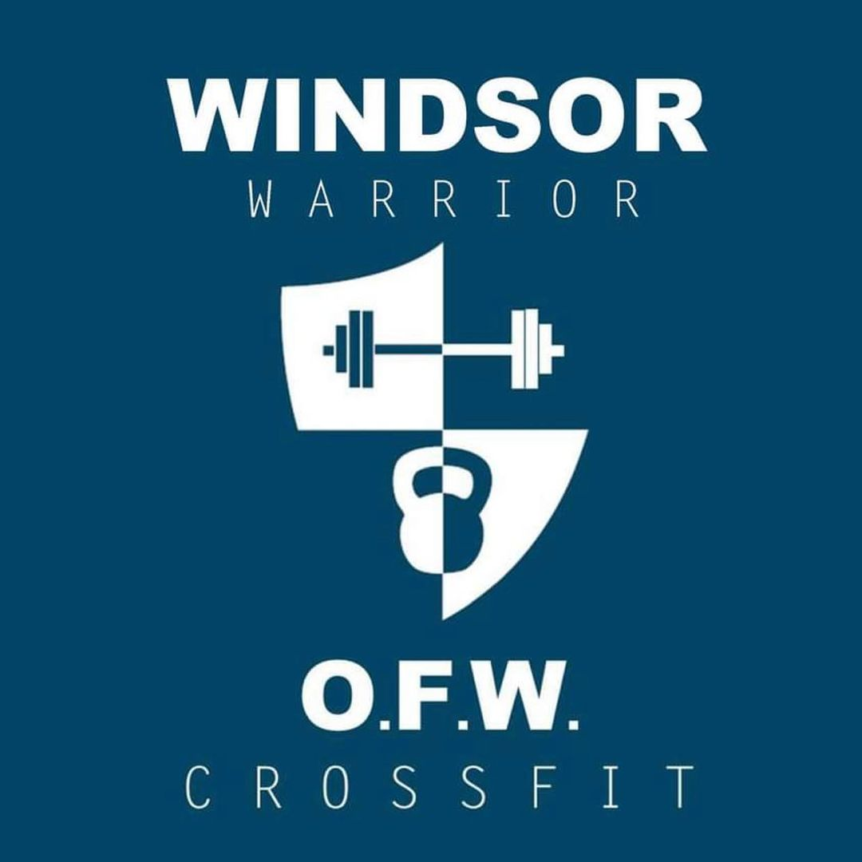

WOD 1: PANIC !!!
Movement Standards
Burpee over Bar  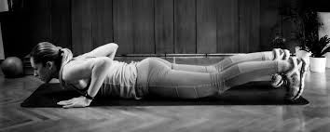 | - Chest and thighs touch ground on burpee  - Step or jump back & up with burpee allowed.  - Two foot take off on jump.  - Must cleanly jump over bar without contact.
Calories  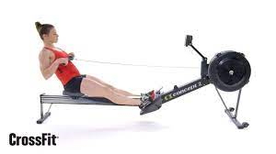 | - Only athletes adjust/touch the rower.

WOD 2: Jerk It
Movement Standard
Jerk From Blocks  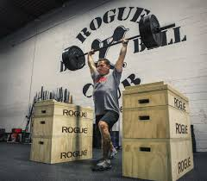 | - Reps start with bumpers on both sides touching blocks.  - Bar must touch shoulders at start of jerk.  - Finish with complete knee, hip, and upper body extension.  - Must demonstrate full control at the finish.  - Split and push jerk allowed.

WOD 3: WTF!!! Wow, That’s Fantastic!

Movement Standard
Overhead Squats  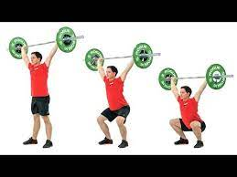 | - At bottom of movement, knees must be above hip crease.  - Finish with full extension of legs and hips  - The bar is overhead and not in contact with the body during reps.
Pull-Ups  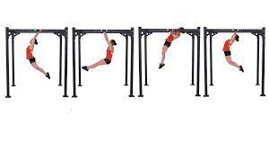 | - Start with arms in full extension.  - Athletes chin travels above the bar at finish
Deadlifts  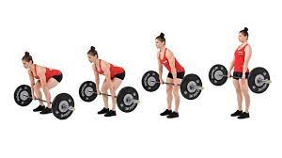 | - Bar starts on floor and both sides must touch the floor between reps.  - Finish in full knee and hip extension with shoulders behind bar
Box Jump Overs  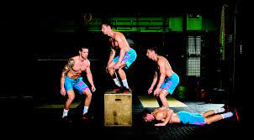 | - Burpee: chest and hips contact ground at same time  - Jump-over: Both feet must take off at same time and land on top of the box at same time.  - Step or jump down allowed.

WOD 4: Jumping Toes to Balls

Movement Standard
Toes to Bar  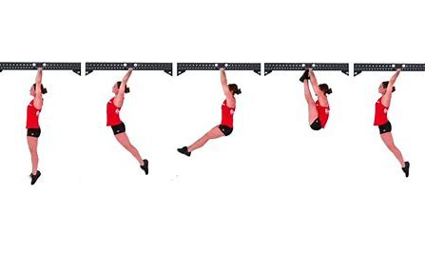 | - Start with arms in full extension.  - At the start, both feet must travel behind the post.  - Athletes’ feet must contact the bar between the hands at the same time.
Wallballs  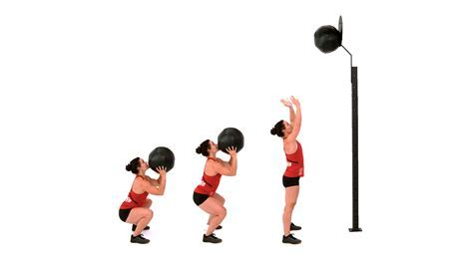 | - Ball hits at or above given target.  - Ball is on floor during rest.
Double Under  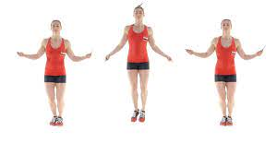 | - Rope must pass under the feet 2x with every jump.  - Athlete must not travel outside of their assigned lane.

